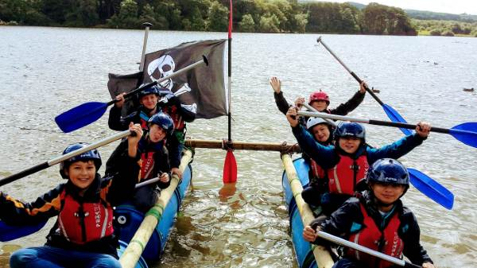



BRAMPTON AREA ACTION GROUP
SPRING HALF TERM SPORTS & ACTIVITIES CAMPS
VENUES: BRAMPTON COMMUNITY CENTRE
WILLIAM HOWARD SCHOOL
CARLISLE UNIVERSITY
TALKIN TARN
BRAMPTON GOLF CLUB

Brampton Area Action Group have again secured funding to provide activities and lunch for children over the Spring Half Term Period. The activities programme is deliberately diverse to ensure all children have a choice of things to try. Activities range from 2 day camps for ages 5 - 18 years, Playschemes for preschool up to 11 years, golf taster lessons for ages 8 - 18 years and a family fun session with Wheels of Wellness for all ages.

ALL ACTIVITIES ARE FREE

However if you would wish to give a small donation to support Brampton Area Action Group and the work they do this would be greatly appreciated - details can be found at www.bramptonareaactiongroup.co.uk.

TIMETABLE: BRAMPTON SPRING HALF TERM ACTIVITIES PROGRAMME 2021

DAY/DATE | TIMES | DESCRIPTION | AGEs | LOCATION | PROVIDER
Tue  1 June | 10 - 12pm | BCC Playscheme | 3 - 4 yrs | Brampton Community Centre | Brampton Community Centre
Tue  1 June | 2pm - 4pm | BCC Playscheme | 5 - 11 yrs | Brampton Community Centre | Brampton Community Centre
Tue  1 June | 8.15am - 3.30pm | Multisports | 5 - 13 yrs | Cumbria University - transport provided | Multisports
Tue  1 June | 9.30am - 3pm | Talkin Adventures | 8-12 yrs | Talkin Tarn | Talkin Adventures
Tue  1 June | 9.30am - 3pm | Talkin Adventures | 13-18 yrs | Talkin Tarn | Talkin Adventures
Wed  2 Jun | 8.15am - 3.30pm | Multisports | 5 - 13 yrs | Cumbria University - transport provided | Multisports
Wed  2 June | 9.30am - 3pm | Talkin Adventures | 8-12 yrs | Talkin Tarn | Talkin Adventures
Wed  2 June | 9.30am - 3pm | Talkin Adventures | 13-18 yrs | Talkin Tarn | Talkin Adventures
Wed  2 June | 10am - 4pm | Wheels of Wellness | All ages | William Howard Car Park | Wheels of Wellness
Thur  3 Jun | 10am-12pm | Playscheme | 3 - 4 yrs | Brampton Community Centre | Brampton Community Centre
Thur  3 Jun | 10am-12pm | Playscheme | 5 - 11 yrs | Brampton Community Centre | Brampton Community Centre
Thur  3 June | 1pm - 2pm | Golf Tasters | 8-12yrs | Brampton Golf Club | Brampton Golf Club
Thur  3 June | 2pm - 3pm | Golf Tasters | 13-15yrs | Brampton Golf Club | Brampton Golf Club
Thur  3 June | 3pm - 4pm | Golf Tasters | 16-18yrs | Brampton Golf Club | Brampton Golf Club
Wheels of Wellness are limited to 20 participants per 30/60 minute session and will run out of the William Howard Car Park. Sessions will run from 10:00am - 16:00.
Talkin Tarn Camps are limited to 8 children/young adults per 'bubble' with a total of 16 children/young adults.
Multisports Camps at Cumbria University Campus are limited to 15 per ‘bubble’ with a total of 45 children per camp, 30 places have been allocated to Brampton Area Action Group children. Transport will be provided from William Howard School to Cumbria University and back for those who need it. We can arrange pickup for children from the Scotby or Warwick Bridge area on the main bus route. Please confirm when booking if this is required.
Brampton Golf Taster Lessons all equipment for the taster lesson will be provided by Brampton Golf Course.
Brampton Community Centre Playschemes children in the morning sessions will be provided with a packed lunch courtesy of our food initiative project SHINE that they can take home with them.
All providers are fully insured for any injury sustained (not from the sport/activity) by an attendee at the event as a result of negligence. There is no cover in place for children if they are to sustain injury during any sporting activity.
Places are limited on a first come first served basis. In the event of withdrawal from a place on a camp, please inform Brampton Area Action Group immediately (tel: 01697 927005/6) so that we can offer that space up to other children on our waiting lists.
PHOTOGRAPHS. By booking you give permission for Wheels of Wellness, Brampton Community Centre, Multi-Sports and Talkin Adventures and Brampton Golf Club the option to take photographs of your child(ren) whilst at the events. These photos will be used for promotion on the providers and organisers websites and on social media if felt appropriate. If you wish for photographs not to be taken or used for promotion, please state so by ticking the box on the booking form.
Brampton Area Action Group collects and uses personal information only for the purpose of booking onto these events and in accordance with applicable Data Protection and Privacy laws, including the Data Protection Act 1998 and the General Data Protection Regulation.
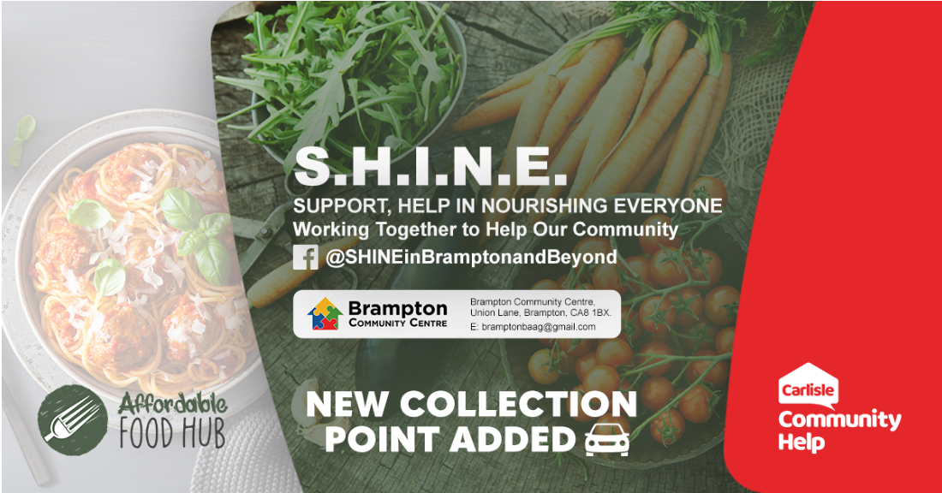
Brampton Area Action Group have also launched Brampton's first Affordable Food Hub in partnership with Carlisle Community Help, for those families who are on benefits or finding it difficult to make ends meet in the current climate and need a little additional help and support in order to ensure they have good nutritious food available. So if you have families on low income, benefits, or know of people who have recently lost their jobs, then Brampton’s Affordable Food Hub may be able to help reduce some of the financial burden. All orders are provided with free fruit and vegetables.

Register with the Affordable Food Hub on www.carlislecommunityhelp.co.uk or contact S.H.I.N.E. Help Desk on 01697 927005 for more information.

S.H.I.N.E. continues to provide emergency food parcels, including fresh fruit and vegetables for anyone who is in need.
------------------------------------------------------------------------------------------------------------------------------------------------------------
SPRING HALF TERM
SPORTS & ACTIVITIES CAMP
BOOKING FORM
Parent’s Name: ………………………………………. Child’s Name: …………………………………………...
Parent Contact Details ............................................... Secondary Contact .......................................................
Email address ………………………………………… School Attended:..........................................................
Child's Age .......................................................... Any Allergies ..............................................................................
Any Disabilities………………………………………………………………………………………………………
Please tick the right hand box to confirm which event you would like your child to attend.
Activity/Dates | Time | Tues 1 June | Wed 2 June | Thu 3 June | Please tick to secure place | Transport Required  Multisport Only
BCC Playscheme | 10.00 - 12.00 | 3 - 4 yrs |  | 3 - 4 yrs
BCC Playscheme | 14.00 - 16.00 | 5 - 11 yrs |  | 5 - 11 yrs
Multisport | 08.15 - 15.30 | 5 - 13 yrs | 5 - 13 yrs
Talkin Adventures | 09.30 - 15.30 | 5 - 12 yrs | 5 - 12 yrs
Talkin Adventures | 09.30 - 15.30 | 13 - 18 yrs | 13 - 18 yrs
Wheels of Wellness | 10.00 - 11.00 |  | Family
Wheels of Wellness | 11.00 - 12.00 |  | Family
Wheels of Wellness | 13.00 - 14.00 |  | Family
Wheels of Wellness | 14.00 - 15.00 |  | Family
Wheels of Wellness | 15.00 - 16.00 |  | Family
Brampton Golf | 13.00 - 14.00 |  |  | 8 - 12 yrs
Brampton Golf | 14.00 - 15.00 |  |  | 13 - 15 yrs
Brampton Golf | 15.00 - 16.00 |  |  | 16 - 18 yrs
If you have more than one child who would like to take part in an event, please complete one form for each child.
Please return this form to your school before 21st May to secure your place.

